**Extra Assignment**

**Q1) Illustrate the need for Pug Package**

**Answer:**  
Pug is a high-performance template engine heavily used in web development with Node.js. It simplifies HTML creation by allowing developers to write cleaner, shorter, and more readable code using indentation instead of closing tags.  
The need for Pug arises because:

* It reduces the complexity of writing large HTML files.
* It helps in dynamic rendering of HTML by embedding JavaScript logic inside templates.
* It improves code maintainability and readability.
* It supports reusability with templates and layouts.
* It speeds up web development by reducing repetitive HTML coding.

Q2) **Implement a small application using the Pug package (I/P, O/P)**

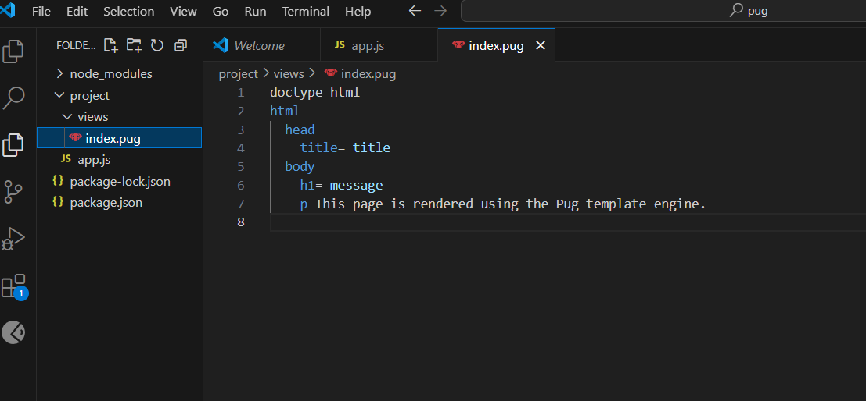

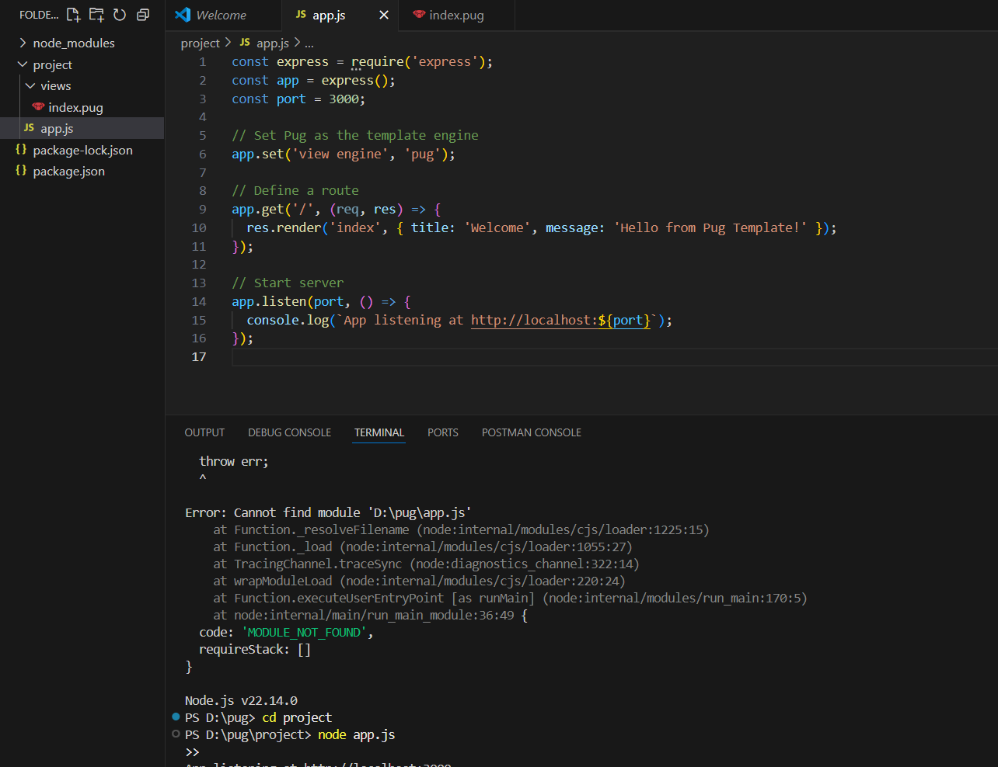

**Output :**

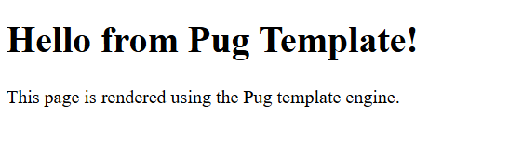

**Q3) Illustrate the need for Code of Ethics**

**Answer:**  
A **Code of Ethics** in web development is essential to guide the professional behavior of developers. It ensures:

* Protection of user privacy and data security.
* Responsibility towards creating accessible, inclusive websites.
* Honesty in representing work and avoiding plagiarism.
* Building trust with clients, employers, and users.
* Maintaining professionalism and respecting intellectual property rights.

Following a code of ethics helps promote fairness, responsibility, and accountability in the software development industry.